ABOUT THE PROGRAMME:  In July 2010 the MA programme in Gender and Development Studies was launched in the Distance (ODL) mode. After successful completion of the first year courses, a learner has an exit option and would earn a Postgraduate Diploma in Gender and Development Studies.  The programme is likely to be of interest to academics and researchers; trainers, facilitators, supervisors; staff of organizations working in the area of gender and development; government personnel; personnel working in banks/ financial institutions.  PROGRAMME OBJECTIVES:  The programmes seek to enable learners to:  - Analyze extent of gender-sensitivity of development interventions;  - Conduct gender analysis;  - Critically analyze gender differentials in selected development sectors;  - Identify appropriate research designs and methodologies for a range of research problems;  - Discuss and suggest positive affirmative action in development planning and practice to promote gender equity and equality: and  - Describe experiences during internship or conduct a field-based research project.  PROGRAMME STRUCTURE:  The broad structure for the Master’s Degree/ PG Diploma in Gender and Development Studies uses a modular approach.  The Year I courses, if successfully completed, would earn the learner a Postgraduate Diploma in Gender and Development Studies. If the learner continues with the Year II courses and successfully completes them, the  YEAR II: COMPULSORY COURSE  In addition to the 32 credits worth electives, learners enrolled for the ODL mode would also have to complete the internship/field-based research project worth 4 credits, thus earning 36 credits in the second year.  ELIGIBILITY: Graduation in any discipline.  CAREER OPPORTUNITIES:  Students completing this programme will be able to pursue their careers in the following areas:  - Can opt for higher studies and research programmes.  - Possibilities to work with Non-Profit Organizations both at National and International level.  - Careers in teaching and research.  - Can pursue careers in specialized areas like Corporate Social Responsibility, Gender Training Programmes, Special Column Writing, Editing, and Mass Media.  PROGRAMME FEE:  MAGD (Distance Mode):  Rs.4,500/- per year. Fees are liable to change and may be checked from Common Prospectus available on IGNOU website-http://www.ignou.ac.in/ |  | learner would earn a Master’s degree in Gender and Development Studies. Specializations according to the learner’s interest could be chosen from a range of optionals using a choice-based credit system.  Learners enrolled for the ODL mode would also complete an internship / field-based research project worth 4 credits in both Year I and Year II. This would provide them exposure to real-life settings and contexts and prepare them for work in governmental and non-governmental organizations or academic institutions.  YEAR I: COMPULSORY COURSES  Learners would be required to complete six compulsory courses over a year in the ODL mode. They would complete 36 credits in the first year (ODL mode).  * One credit equals 30 student study hours  PROGRAMME COORDINATORS (Distance mode)  Prof.Annu J Thomas  School of Gender and Development Studies  Indira Gandhi National Open University  Maidan Garhi  New Delhi – 110 068  E-mail: athomas@ignou.ac.in  Ph.No:011-29571611, 64788934  Prof.Savita Singh  School of Gender and Development Studies  Indira Gandhi National Open University  Maidan Garhi  New Delhi – 110 068  E-mail: savitasingh@ignou.ac.in  Ph.No: 011-29571613  FOR FURTHER INFORMATION PLEASE CONTACT  Director  School of Gender and Development Studies  Indira Gandhi National Open University  Maidan Garhi  New Delhi – 110 068  E-mail: sogds@ignou.ac.in  Ph.No: 011-29571611, 64788934  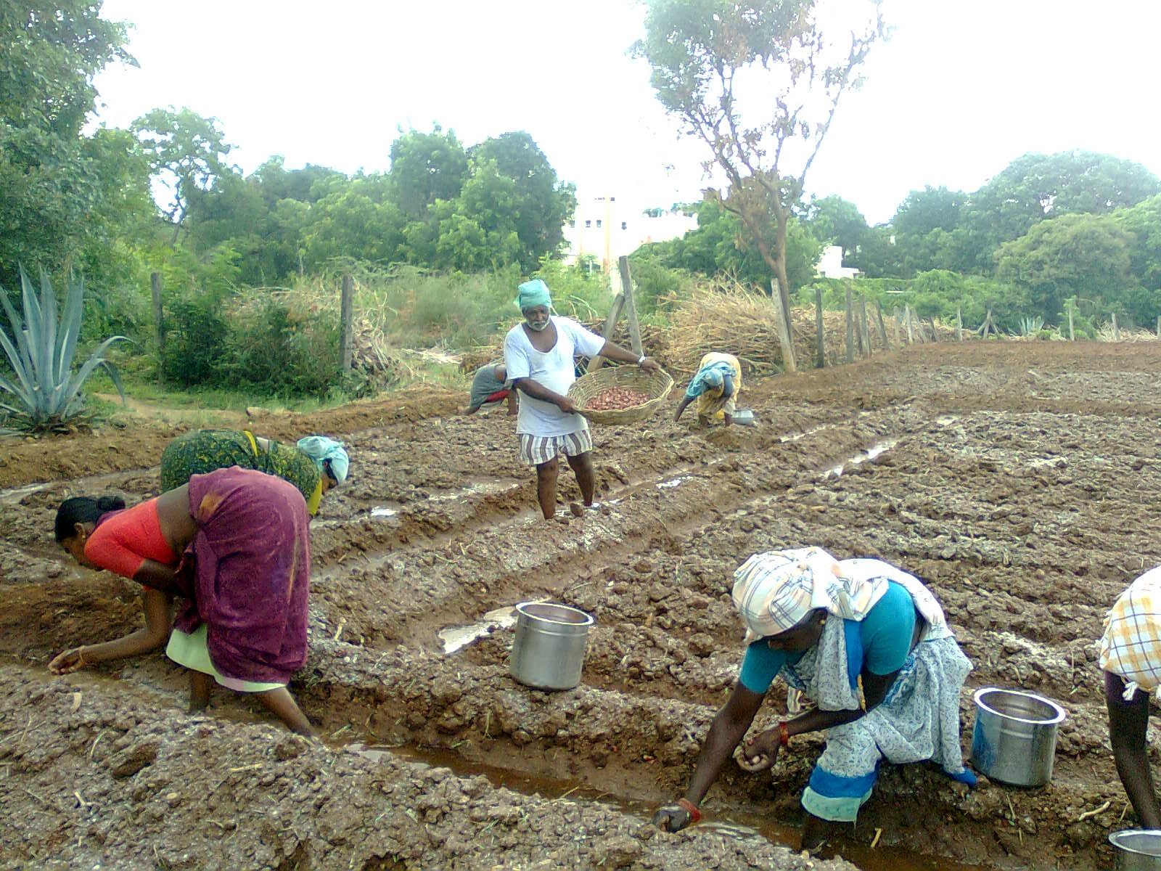 |  | YEAR II: COURSE ELECTIVES  Learners would be required to complete eight optional courses over one year (ODL mode). They would complete a total of 32 credits worth of electives in the second year. Electives presently on offer include:    M.A in Gender and Development Studies  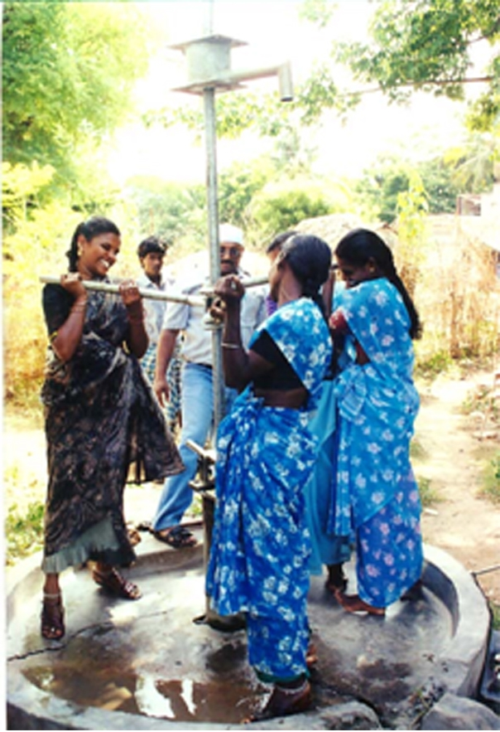  School of Gender and Development Studies  Indira Gandhi National Open University  New Delhi  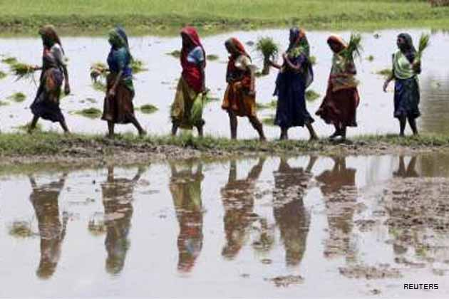
  S.No | Course Code | Course Title | Credits
  1. | MGSP-002 | Internship-II/Field-based Research Project-II | 4
  S.No. | Course Code | Course Title | Credits*
  1. | MGS-001 | Gender and Development: Concept, Approaches and Strategies | 6
  2. | MGS-002 | Gender, Development Goals and Praxis | 6
  3. | MGS-003 | Gender Analysis | 4
  4. | MGS-004 | Gender-sensitive Planning and Policy Making | 8
  5. | MGS-005 | Research Methodologies in Gender and Development Studies | 8
  6. | MGSP-001 | Internship-I/Field-based Research Project-I | 4
  S.No | Course Code | Course Title | Credits
  1. | MGSE-001 | Gender Planning and Development Policies | 4
  2. | MGSE-002 | Gender Audit and Gender Budgeting | 4
  3. | MGSE-003 | Gender Mainstreaming | 4
  4. | MGSE-004 | Gender Issues in Agriculture, Rural Livelihoods and Natural Resource Management | 4
  5. | MGSE-006 | Gender, Resources and Entitlements | 4
  6 | MGSE-007 | Gender, Organization and Leadership | 4
  7. | MGSE-009 | Gender Issues in Work, Employment and Productivity | 4
  8. | MGSE-0010 | Gender, Entrepreneurship and Development | 4
  9. | MGSE-0013 | Gender Training and Empowerment | 4
  10. | MGSE-0020 | Gender and Financial Inclusion | 4

